

**Practical course report II**

Hamza Es-samlaly

Youssef Bouslama

Objectives

Execute the whole code for each of the four given assignments, strating with manipulating QHBoxLayout, then Nested Layouts, Bug Report Form, and lastly the Grid Layout.

hbox.cpp:

#include "mainwindow.h"

#include <QApplication> #include <QHBoxLayout> #include <QLineEdit> #include <QPushButton> #include <QLabel>

int main(int argc, char* argv[])

{

QApplication app(*argc*, *argv*);

QWidget* window = new QWidget();

window->setWindowTitle("QHBoxLayout Test"); window->resize(300,50);

auto layout = new QHBoxLayout; window->setLayout(*layout*);

auto label = new QLabel("Name:"); label->show();

auto text = new QLineEdit;

auto button = new QPushButton("Search"); layout->addWidget(*label*);

layout->addWidget(*text*); layout->addWidget(*button*);

window->show();

return app.exec();

}

Here’s the output of the program:

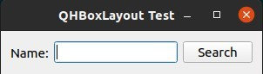

the layouts that needed to be added:

nestelayout.h:

#include <QMainWindow>

#include <QLineEdit> #include <QPushButton> #include <QHBoxLayout> #include <QLabel> #include <QVBoxLayout> #include <QBoxLayout> #include <QCheckBox>

class NestedLayout : public QWidget

{

Q_OBJECT

public:

*//constructor*

NestedLayout(QWidget *parent = nullptr);

protected:

void createWidgets(); void placeWidgets();

private:

QLabel *label; QLineEdit *line; QPushButton *search; QPushButton *close; QCheckBox *match; QCheckBox *backword; QHBoxLayout *layoutP; QVBoxLayout *layoutS;

};

nestedlayout.cpp:

#include "nestedlayout.h"

#include "ui_mainwindow.h" #include <QWidget>

NestedLayout::NestedLayout(QWidget *parent) : QWidget(*parent*)

{

createWidgets(); placeWidgets();

}

void NestedLayout::createWidgets(){ label = new QLabel("Name:"); line = new QLineEdit();

search = new QPushButton("Search"); close = new QPushButton("Close"); match = new QCheckBox("Match case");

backword = new QCheckBox("Search Backward");

layoutP = new QHBoxLayout(); layoutS = new QVBoxLayout();

}

void NestedLayout::placeWidgets(){ auto mainLayout = new QHBoxLayout; auto leftLayout = new QVBoxLayout;

auto topLeftLayout = new QHBoxLayout; auto RightLayout = new QVBoxLayout;

setLayout(*mainLayout*);

leftLayout->addLayout(*topLeftLayout*); leftLayout->addWidget(*match*); leftLayout->addWidget(*backword*);

topLeftLayout->addWidget(*label*); topLeftLayout->addWidget(*line*);

RightLayout->addWidget(*search*); RightLayout->addWidget(*close*); RightLayout->addStretch(1);

mainLayout->addLayout(*leftLayout*); mainLayout->addLayout(*RightLayout*);

}

main.cpp:

#include "nestedlayout.h"

#include <QApplication>

int main(int argc, char *argv[])

{

QApplication app(*argc*, *argv*); auto window = new NestedLayout;

window->setWindowTitle("Netsted layout test"); window->show();

return app.exec();

}

And here’s the output as requested:

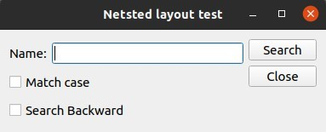

bugreport.h:

#include <QWidget> #include <QLabel> #include <QLineEdit> #include <QPushButton> #include <QLayout> #include <QSpinBox> #include <QFormLayout>

#include <QDialogButtonBox> #include <QVBoxLayout> #include <QComboBox> #include <QTextEdit>

class BugReport: public QWidget{

Q_OBJECT

public:

BugReport(QWidget * parent = nullptr);

protected:

void createWidgets(); void placeWidgets();

protected:

QVBoxLayout * mainlayout;

QFormLayout *layout;

QLineEdit * line1; QLineEdit * line2; QLineEdit * line3; QLineEdit * line4; QLineEdit * line5; QTextEdit * line6;

QComboBox * combo;

QVBoxLayout * v1layout; QVBoxLayout * vlayout;

QDialogButtonBox * buttonbox;

};

bugreport.cpp:

#include "bugreport.h"

#include <QWidget> #include <QLayout> #include <QFormLayout> #include <QApplication> #include <QVBoxLayout>

BugReport::BugReport(QWidget * parent): QWidget(*parent*){

*//Creatign the widgets*

createWidgets();

*//place Widgets*

placeWidgets();

}

void BugReport::createWidgets()

{

mainlayout = new QVBoxLayout();

layout = new QFormLayout;

line1 = new QLineEdit(); line2 = new QLineEdit(); line3 = new QLineEdit(); line4 = new QLineEdit(); line5 = new QLineEdit(); line6 = new QTextEdit();

buttonbox = new QDialogButtonBox;

}

void BugReport::placeWidgets()

{

layout->addRow(tr("&Name:"), *line1*); layout->addRow(tr("&Company:"), *line2*); layout->addRow(tr("&Phone:"), *line3*); layout->addRow(tr("&Email:"), *line4*);

layout->addRow(tr("Problem &Title:"), *line5*); layout->addRow(tr("&Summary Information:"),*line6*);

combo = new QComboBox;

combo->addItem(tr("Always")); combo->addItem(tr("Sometimes")); combo->addItem(tr("Rarely"));

layout->addRow(tr("&Reproducibility:"),*combo*);

buttonbox->addButton(tr("Submit Bug Report"), QDialogButtonBox::*AcceptRole*);

buttonbox->addButton(tr("Don't Submit"), QDialogButtonBox::*RejectRole*);

buttonbox->addButton(QDialogButtonBox::*Reset*);

mainlayout->addLayout(*layout*); mainlayout->addWidget(*buttonbox*); setLayout(*mainlayout*);

}

main.cpp:

#include "bugreport.h"

#include <QApplication>

int main(int argc, char *argv[])

{

QApplication a(*argc*, *argv*); BugReport w;

w.show();

return a.exec();

}

And here’s the output of the code:

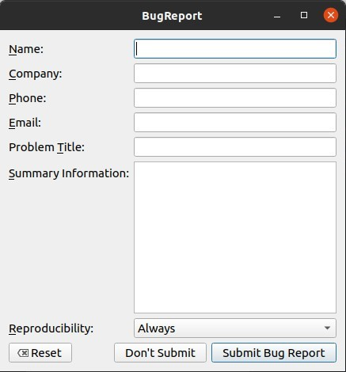

And last we have the grid layout

gridlayout.h:

#ifndef GRIDLAYOUT_H

#define GRIDLAYOUT_H #include <QtWidgets>

#pragma once namespace Ui { class calculator;

}

class GridLayout : public QWidget

{

public:

*//constructor*

explicit GridLayout(QWidget *parent = nullptr); void creatingWdgets();

void positionWidgets(); void makeConnections();

private:

QPushButton *buttons[10]; QPushButton *bEnter; QLCDNumber *lcd; QVBoxLayout *mainLayout; QGridLayout *grid;

};

#endif *// GRIDLAYOUT_H*

gridlayout.cpp:

#include "gridlayout.h"

#include <string>

GridLayout::GridLayout(QWidget* parent):QWidget(parent)

{

creatingWdgets(); positionWidgets();

}

void GridLayout ::creatingWdgets(){ for(int i=0;i<10;i++){

QString s = QString::number(9-i); buttons[i]=new QPushButton(s);

}

bEnter =new QPushButton("enter"); lcd = new QLCDNumber();

lcd->setSegmentStyle(QLCDNumber::Flat);

}

void GridLayout :: positionWidgets(){ mainLayout = new QVBoxLayout(); grid = new QGridLayout();

int k = 0;

for(int i=1;i<4;i++){ for(int j=0;j<3;j++){

grid->addWidget(buttons[k],i,2-j); k++;

lcd->setMinimumHeight(80); lcd->setDigitCount(6);

}

}

grid->addWidget(buttons[9],4,0); grid->addWidget(bEnter,4,1,1,2); mainLayout->addWidget(lcd); mainLayout->addLayout(grid); resize(300,300); setLayout(mainLayout);

}

main.cpp:

#include <QApplication>

#include "gridlayout.h"

int main(int argc, char *argv[])

{

QApplication a(argc, argv); GridLayout D;

D.show();

return a.exec();

}

And finally here’s the requested output:

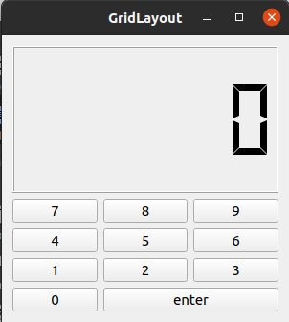

# **Conclusion**

Very fun to code , thank you for your time .